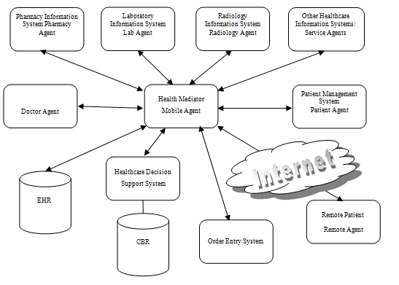

**TEAM ID**

**-**

**PNT2022TMID38716**

**SOLUTION ARCHITECTURE**

**FOR**

**Analytics for Hospitals Health – Care Data**